Face Detection
Multi-Factor Driver Authentication System · Phase 1

1. Overview
Phase 1 implements the core computer-vision pipeline: face detection, driver registration, real-time face recognition, and automatic LED lighting control. It is software-only and runs on a standard PC or Raspberry Pi with an attached USB/CSI camera.

1.1 Project Context
Modern commercial vehicles require secure authentication to prevent unauthorized use. Phase 1 replaces key-based access with face recognition, using a multi-pose registration process (inspired by iPhone Face ID) to build a robust facial model that works under varying lighting conditions.

1.2 Key Features
- Strict Haar Cascade face detection (centre-zone only, high confidence)
- iPhone-style multi-pose registration — 5 poses × 2 lighting conditions × 20 samples = 200 samples
- LBPH (Local Binary Patterns Histogram) face recognizer
- Multiple-face alert — access blocked if more than one person is detected
- Debounced LED relay control — hysteresis prevents flickering
- CSV event logging with timestamps

Phase Scope
Phase 1 covers face detection, registration, and authentication only. Fingerprint authentication and SD-card logging are later-phase features.

2. System Architecture

2.1 Module Overview
Module | Responsibility
Face Detection | Detects faces in the centre zone using OpenCV Haar Cascades with strict parameters (minNeighbors=8, minSize=100×100).
Registration | Guides the driver through 5 poses × 2 lighting conditions, capturing 20 frames per sub-pass, and trains LBPH.
Authentication | Compares the live face ROI against the stored LBPH model; grants or denies based on a confidence threshold.
LED Controller | Measures central-ROI brightness and debounces LED relay changes with a confirmation timer.

2.2 System Flow
Camera Input → Face Detection → [Registration path / Authentication path] → LED Control → CSV Log.
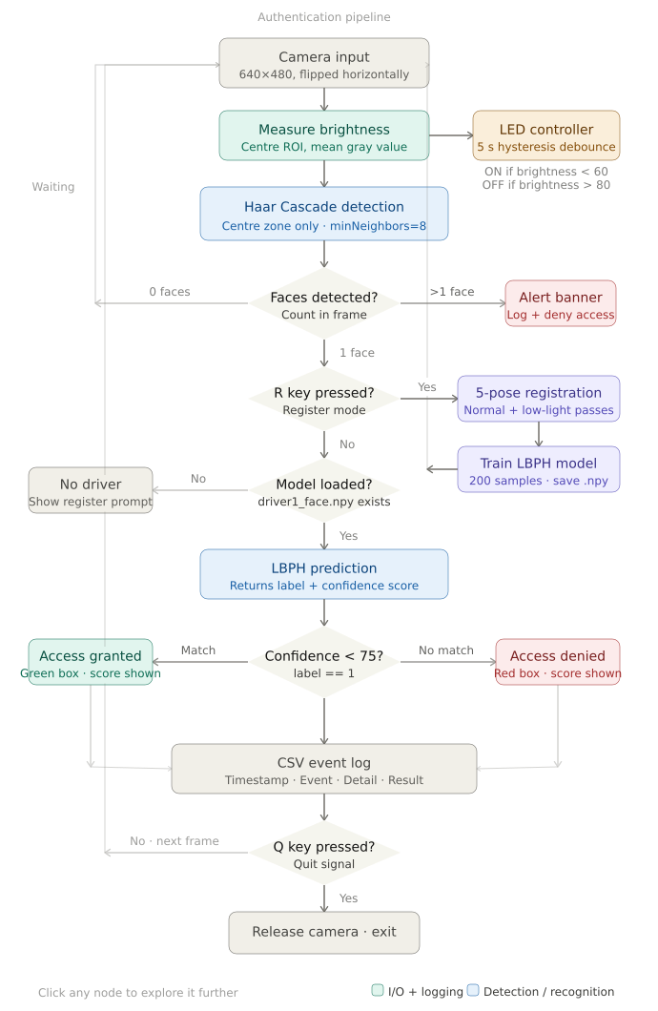
System flow diagram — the full authentication pipeline

3. Face Detection

3.1 Method
Phase 1 uses OpenCV's Haar Cascade classifier (haarcascade_frontalface_default.xml). Detection is restricted to the centre zone of each frame — inset from the edges — to prevent background objects from triggering false detections.

3.2 Detection Parameters
Constant | Value | Description
DETECT_SCALE | 1.1 | Image-pyramid scale factor (smaller = more detections, slower)
DETECT_MIN_NEIGHBORS | 8 | Min neighbour rectangles (higher = fewer false positives)
DETECT_MIN_SIZE | (100, 100) | Minimum face size in pixels
DETECT_ZONE_X | 80 px | Horizontal inset of the detection zone
DETECT_ZONE_Y | 60 px | Vertical inset of the detection zone

3.3 Multiple Face Handling
If more than one face is detected during authentication, a full-width alert banner is shown and access is denied until only one face remains. All multi-face events are logged.
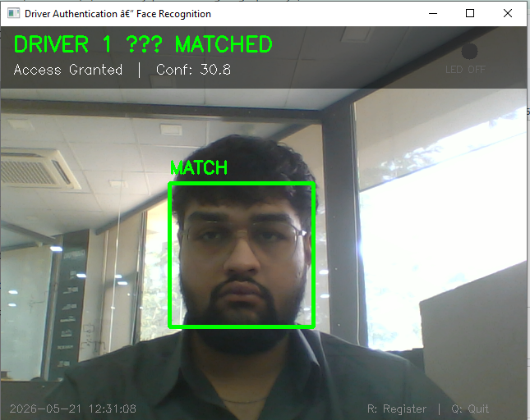  Single face — normal detection | 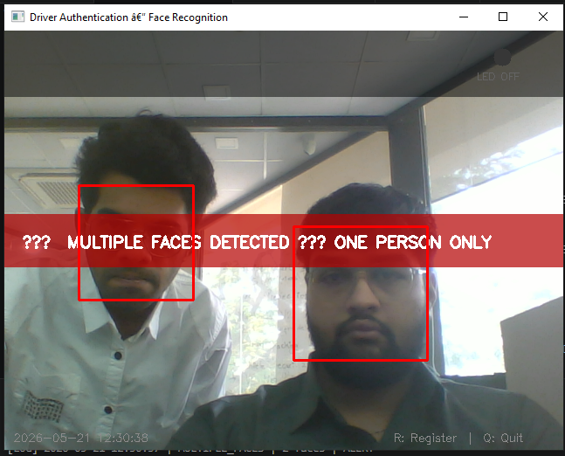  Multiple-face alert — access blocked

3.4 Detection During Registration
During registration, detection is deliberately relaxed (minNeighbors=4, minSize=60×60) to accommodate angled head poses that would otherwise fail the strict authentication-mode detector.

4. Driver Registration

4.1 Overview
Registration follows an iPhone Face ID-style guided capture. The driver completes five head-pose steps; each is captured twice — once under normal lighting and once under simulated low light — ensuring the model is robust to varying conditions.
Sample Count
Each sub-pass captures 20 samples (SAMPLES_PER_STEP). Total = 5 poses × 2 lighting × 20 samples = 200 training samples stored in driver1_face.npy.

4.2 Registration Steps
1 | Look straight at the camera  Baseline frontal view — captured in normal and low light
2 | Slowly turn head RIGHT  Right-profile variation
3 | Slowly turn head LEFT  Left-profile variation
4 | Tilt head UP  Upward-gaze variation
5 | Tilt head DOWN  Downward-gaze variation

4.3 Registration UI
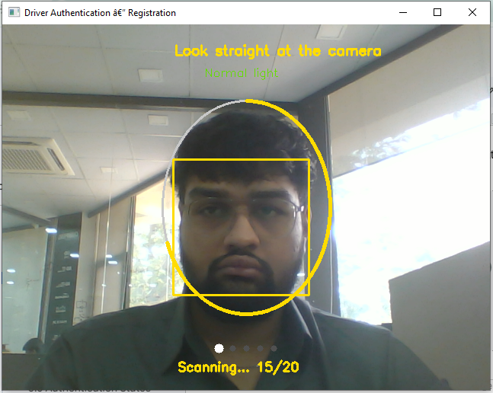  Step 1 — Look straight (normal light) | 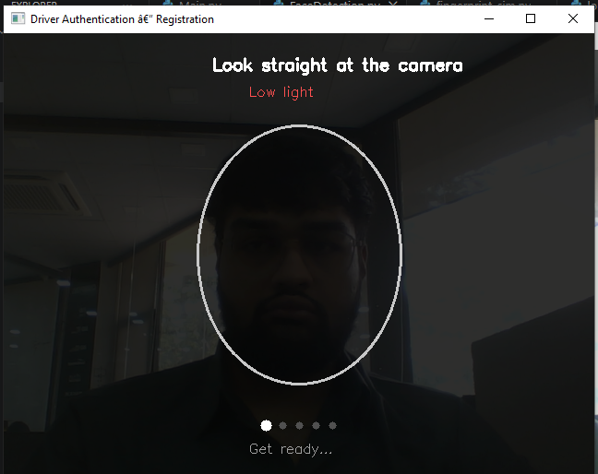  Step 1 — Look straight (low light)
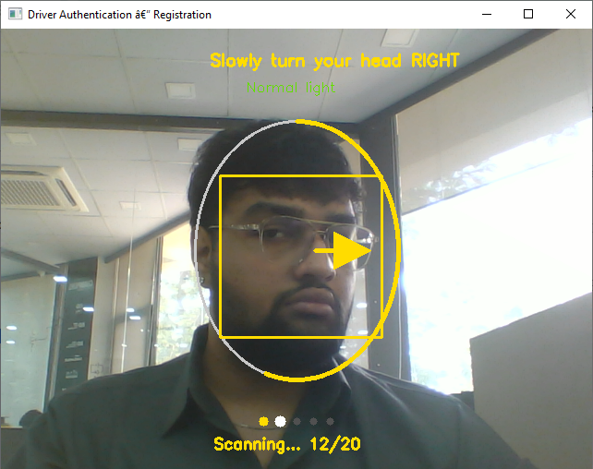  Step 2 — Turn right | 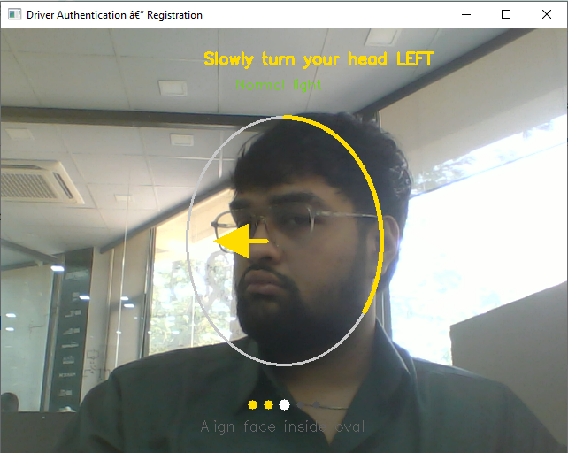  Step 3 — Turn left
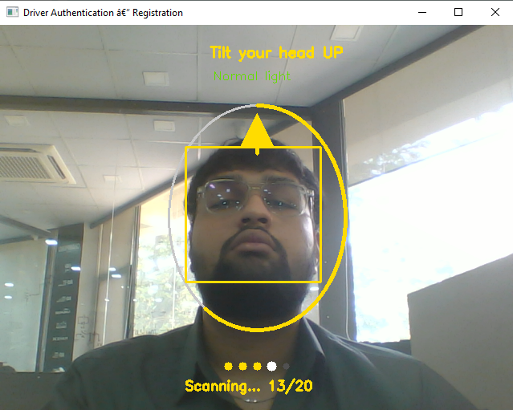  Step 4 — Tilt up | 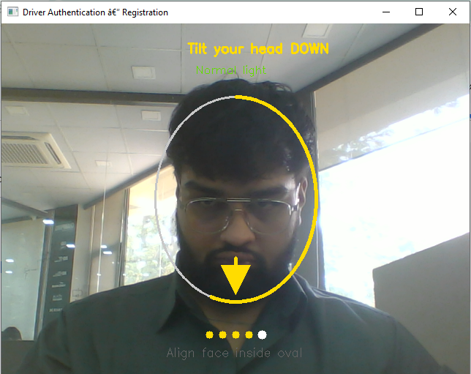  Step 5 — Tilt down

Registration complete — “Driver 1 Registered!”

5. Authentication

5.1 Recognizer
Phase 1 uses OpenCV's LBPH face recognizer. LBPH divides the face ROI into a grid of cells, computes texture histograms per cell, and compares them to the training set. It performs well under minor lighting and pose changes.

5.2 Match Threshold
Lower confidence means a better match. The threshold is configured as:
MATCH_THRESHOLD = 75
# granted if label == 1 and confidence < 75

5.3 Authentication States
State | Condition | Visual Feedback
Access Granted | label=1, conf < 75 | Green box, 'DRIVER 1 — MATCHED', score
Access Denied | label≠1 or conf ≥ 75 | Red box, 'NOT MATCHED', 'Access Denied'
No Driver | driver1_face.npy missing | Orange banner — 'Press R to set up Face ID'
Multiple Faces | len(faces) > 1 | Red full-width alert banner
No Face | len(faces) == 0 | Status bar cleared — waiting

5.4 Authentication Screenshots
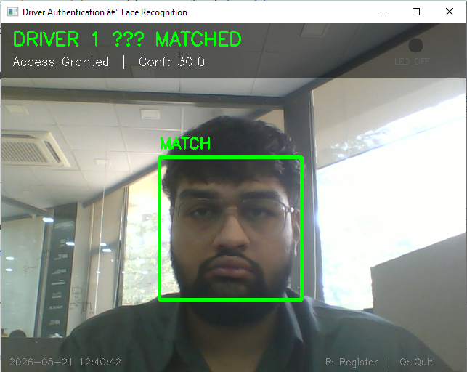  Access granted — green box, confidence shown | 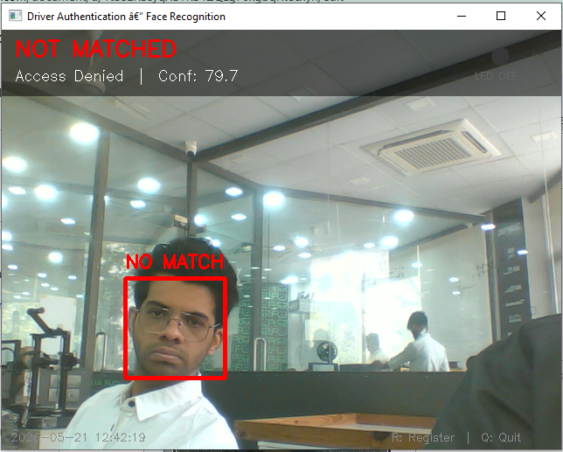  Access denied — red box, NOT MATCHED

6. LED Auto-Lighting

6.1 Brightness Measurement
Each frame, the system measures average pixel brightness in a central region:
def measure_brightness(frame):
h, w = frame.shape[:2]
cx, cy = w // 2, h // 2
roi = frame[cy-75:cy+75, cx-100:cx+100]
return float(np.mean(cv2.cvtColor(roi, cv2.COLOR_BGR2GRAY)))

6.2 Thresholds
Constant | Value | Description
BRIGHTNESS_LOW | 60 | Below this, LED turns ON (low light)
BRIGHTNESS_OK | 80 | Above this, LED turns OFF (good light)
LED_CONFIRM_SECS | 5.0 | Stable-state seconds before the LED switches

6.3 Hysteresis / Flicker Fix
The LED controller debounces state changes: the LED only switches if brightness stays past the threshold for the confirmation window, preventing rapid toggling from noise or momentary shadows.
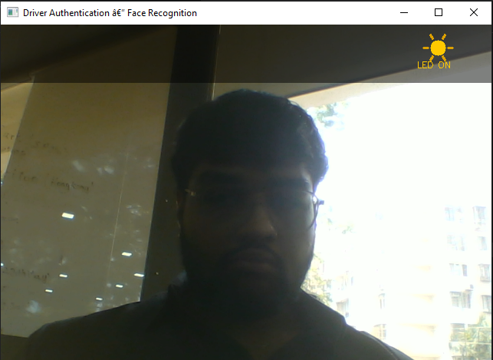  LED ON — low light detected | 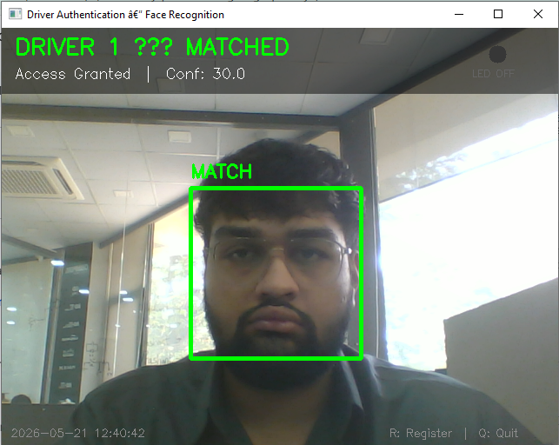  LED OFF — good light

6.4 Hardware Note
Hardware Flag
RELAY_LED_HARDWARE = False by default. In software-only mode the LED state is printed and logged; physical relay control arrives in Phase 3.

7. Event Logging

7.1 CSV Log Format
Field | Example | Description
Timestamp | 2025-05-18 14:32:07 | Date and time of the event
Event | FACE_MATCH | Event type identifier
Detail | conf=42.3 | Additional context
Result | GRANTED | Outcome of the event

7.2 Logged Events
- SYSTEM_STARTED, DRIVER_1_REGISTERED, FACE_MATCH, FACE_NO_MATCH, MULTIPLE_FACES, LED_RELAY, SYSTEM_STOPPED

7.3 Log Screenshot
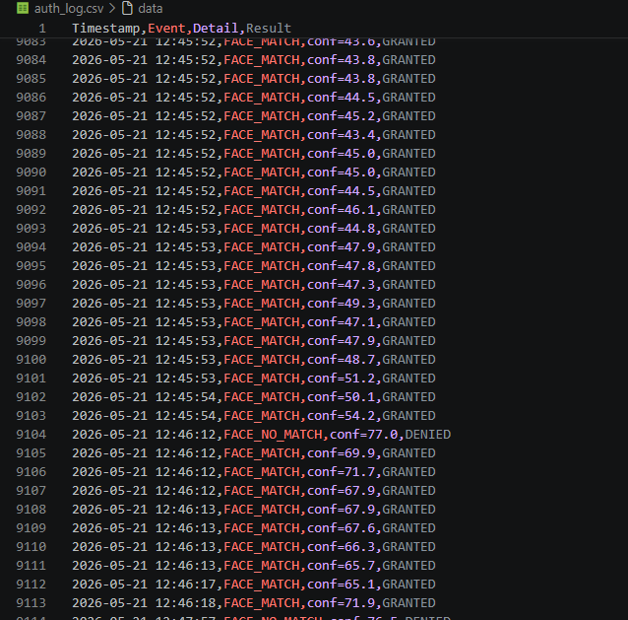
auth_log.csv — timestamped event log

8. Configuration Reference
Constant | Value | Description
CAMERA_INDEX | 0 | Camera device index
FRAME_WIDTH / HEIGHT | 640 × 480 | Capture resolution
DRIVER_FACE_FILE | driver1_face.npy | Saved LBPH model
LOG_FILE | auth_log.csv | Event log path
MATCH_THRESHOLD | 75 | Max LBPH confidence for a match
SAMPLES_PER_STEP | 20 | Samples per lighting sub-pass
BRIGHTNESS_LOW / OK | 60 / 80 | LED on/off brightness thresholds
RELAY_LED_HARDWARE | False | Enable GPIO relay output

9. Controls, Limitations & Next

9.1 Controls & Running
R — start driver registration (re-registration overwrites the model). Q — quit cleanly, releasing the camera and saving the log.
pip install opencv-python opencv-contrib-python numpy
python driver_auth_phase1.py

9.2 Known Limitations
- Haar detection can fail at extreme head angles (>45°), mitigated by relaxed registration parameters.
- LBPH accuracy drops with drastic lighting changes not covered during registration.
- Only one driver profile (Driver 1) is supported in Phase 1.
- LED control is software-only in Phase 1 (physical relay arrives in Phase 3).

9.3 What Comes Next — Phase 2
- Fingerprint sensor integration as a second authentication factor
- Dual-factor access decision combining face and fingerprint

